

CSA0823-Python Programming(Slot C)

Name:
Reg.No:
Assigned Date:
Submitted Date:
Python Data Type,Variable,Function Program Questions
- Swap without a third variable
Two variables a = 10 and b = 25 are given. Swap their values without using a temporary variable. Then explain why your method works.
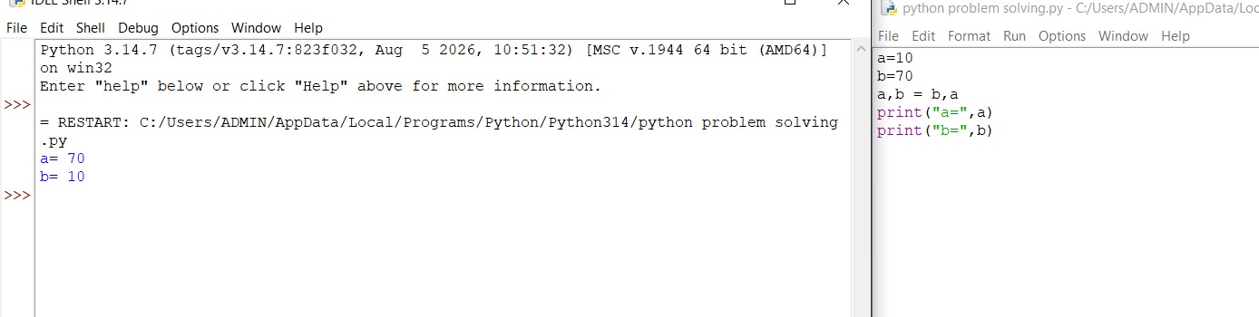
- Predict the type
Without running the code, write the data type of each result, then verify: python
x = 5 / 2
y = 5 // 2
z = "5" * 3
w = (5)
v = (5,)
Which ones surprised you, and why?
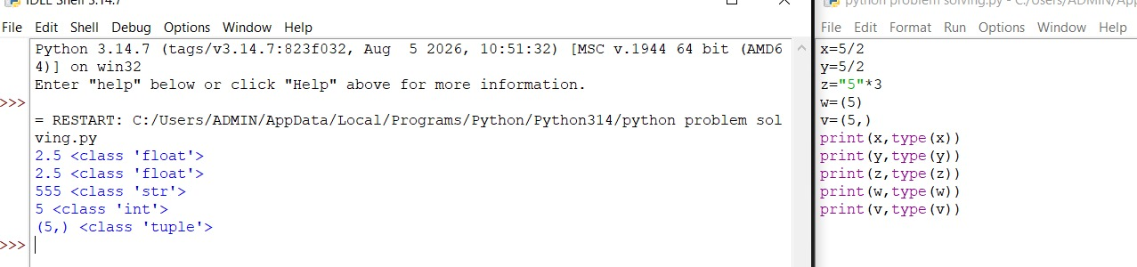
- The mutable trap
python
a = [1, 2, 3]
b = a b.append(4) print(a)

Predict the output. Then change the code so that a stays unchanged. Explain the difference between assignment and copying. 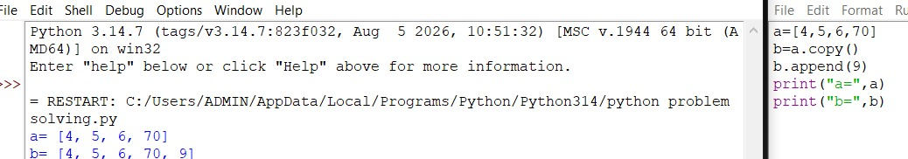
- Temperature converter
Write a function convert(temp, unit) that converts Celsius to Fahrenheit if unit is "C", and Fahrenheit to Celsius if unit is "F". What should it do if the unit is anything else? Decide and justify. 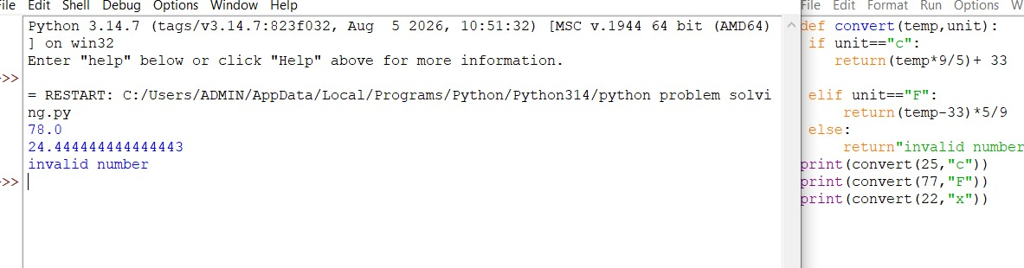
- String detective
Take any sentence typed by the user. Write a program (using variables and string methods) that prints the number of words, the longest word, and the sentence in reverse word order. 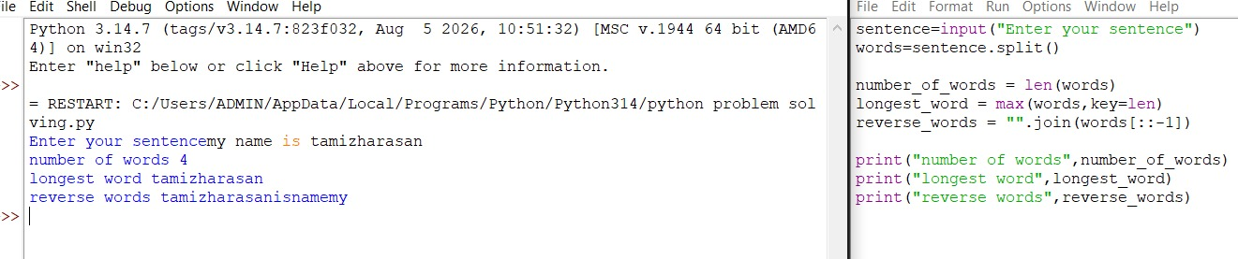
- Fix the scope bug
python count = 0
def increase(): count = count + 1
increase() print(count)
This code gives an error. Find out why, then fix it in two different ways. Which way is better practice? 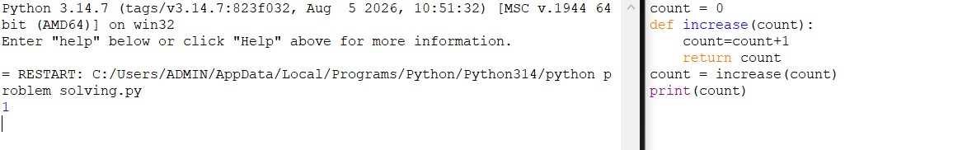
- Function with a default surprise
Write a function greet(name, greeting="Hello") and call it in four different ways (positional, keyword, using the default, and swapping argument order with keywords). Then write one call that would cause an error and explain why. 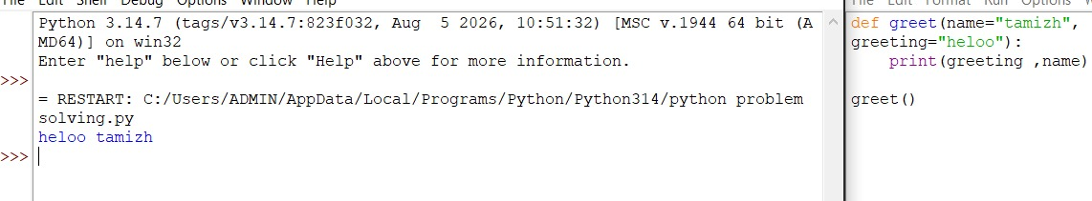
- Data type chooser
You must store each of the following in a Python program. Choose the best data type (int, float, str, list, tuple, set, dict, bool) and justify your choice:
  - a student's roll number
  - marks in 5 subjects
  - the days of the week
  - unique email IDs of club members
  - a student's name along with their age and class
  - whether a library book is issued
- Return multiple values
Write a function analyze(numbers) that takes a list of numbers and returns the minimum,
maximum, and average together. Show two different ways to receive and print the returned values. What data type does the function actually return? 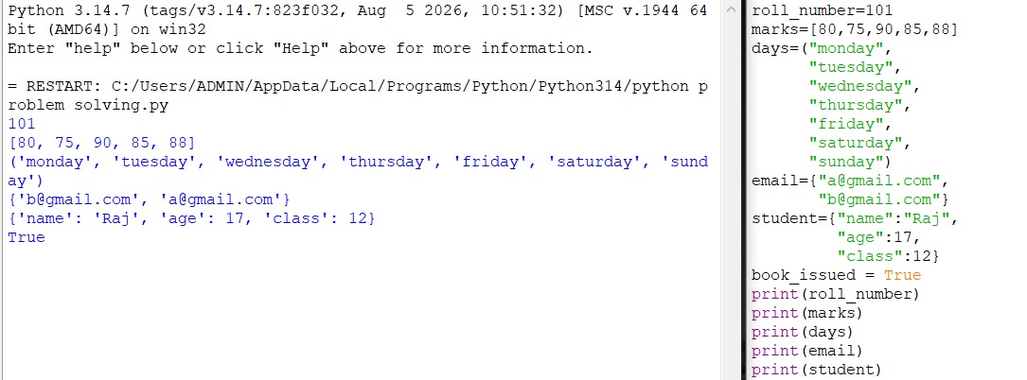
- Build a mini-calculator with validation
Write separate functions for add, subtract, multiply, and divide. Ask the user for two numbers and an operation, and call the right function. Make sure the program doesn't crash on division by zero or when the user types letters instead of numbers. Hint: think about type conversion and where it can fail. 